

**ETHEREUM BEHAVIORAL DESIGN PATTERNS – STATE MACHINE & CONTRACT SELF DESTRUCTION**

Date: 12/04/2018

Brent Anthony Tudas

Sandra Alleine Blanca

Jaymar Dingcong

Robert Aries Dela Paz

Kimberly Mae Reyes

Patrick Oliver Palmero

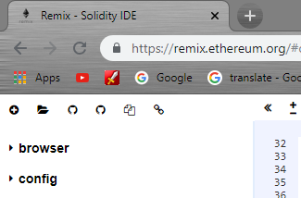**INSTRUCTIONS**

Go to <https://remix.ethereum.org/>

1. Click the icon and go to the folder

Directory of this document and select

Treasury.sol

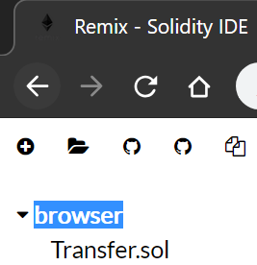

1. Click “browser” and it will collapse  
   find “Treasury.sol” and select it.



1. 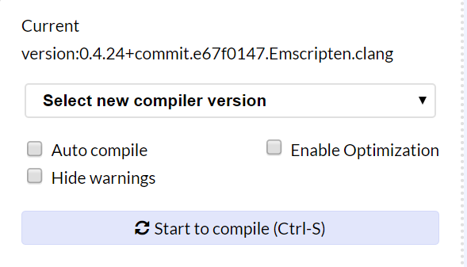Select new compiler version. Set it to 0.4.24+commit version.

Then, select Run tab.

1. Select ***Environment*** change itto JavaScript VM.
2. Select **Account** from the drop down button. Remember you chosen account.
3. 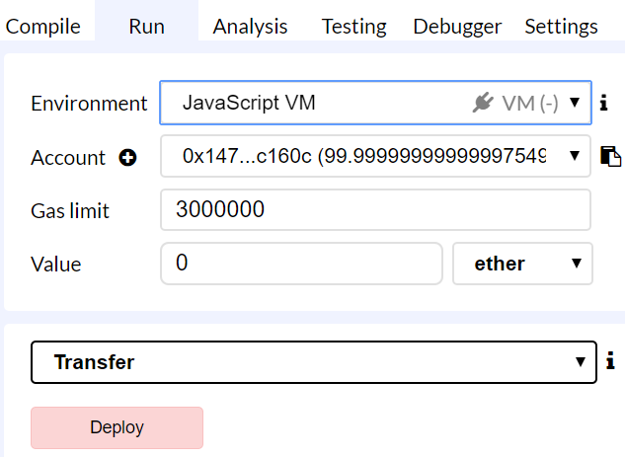 Click **deploy**.

**Create a Collector**

Enter the name of collector inside double quotation. Then click createCollector button to submit.

Ex. “brent”



**Collecting Money**

Find the collectMoney field and provide the address of the collectee and the collected amount. After providing the input click the button.



**Getting Collector’s Info**

Find the getCollector field and put the index of the desired collector there. You should see the following.

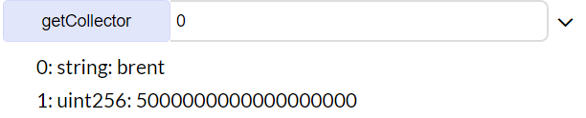

**Create an Auditor**

Make sure to change account first before proceeding.

Find the createAuditor field and provide the name of the auditor and click the button like so.



**Audit collectors collection**

Make sure the account you’re using is an auditor. Then provide the address of the desired collector and the value of the audited amount. After providing the inputs hit audit like so.



Notice the details of the collector audited had been modified since the amount the collector collected has been audited.

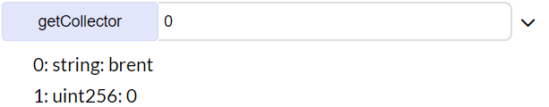

**Getting Auditor’s Info**

Find the getAuditor field and put the index of the desired auditor there. You should see the following.

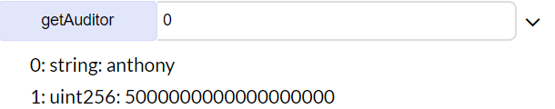

**Sending to Treasury**

Make sure that you are using an auditor account before doing so. Provide the amount of the value to be sent to the treasury.



Then hit sendToTreasury. After clicking it the amount will be sent to the Treasury contract.



Now this is the balance of the treasury.

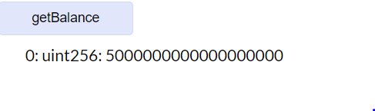

**Withdrawing**

Make sure you’re using the account of the deployer of the contract before proceeding.



Find the withdraw field and provide the desired amount to be withdrawn from the treasury. And click the withdraw button.



After withdrawing the balance of the owner should be like this.



And the balance of the treasury contract should be this.

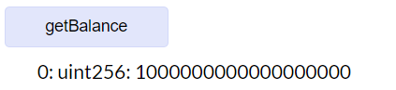

**Terminating the Contract**

Make sure using the account of the deployer before proceeding.



Now the contract will be terminated will not be used.

**References:**

**State Machine Full Description -**

[**http://aqdi.com/articles/using-state-machines-in-your-designs-3/**](http://aqdi.com/articles/using-state-machines-in-your-designs-3/)

**Strategy Pattern VS. State Machine Pattern –**

[**https://javarevisited.blogspot.com/2014/04/difference-between-state-and-strategy-design-pattern-java.html**](https://javarevisited.blogspot.com/2014/04/difference-between-state-and-strategy-design-pattern-java.html)